3. Project Design Phase
Objective

To design the structure and workflow of the Auto Ticket Classification system before starting the development process.

Activities Performed

- Design the overall ticket classification workflow.
- Identify the trigger required to start the flow.
- Design the conditions for different ticket categories.
- Design the actions required after each condition.
- Define category and support group mapping.
- Design the sequence of flow actions.
- Define how the ticket should be updated after classification.
- Design the error or unmatched condition handling.
- Prepare the logical data flow of the system.

System Design

The proposed system consists of the following major components:

1. Ticket Creation – A requester creates a support ticket.
2. Flow Trigger – Flow Designer detects the newly created ticket.
3. Ticket Information – The flow retrieves the required ticket details.
4. Condition Check – Classification conditions are evaluated.
5. Category Assignment – The appropriate category is identified.
6. Group Assignment – The ticket is assigned to the relevant support group.
7. Ticket Update – The ticket is updated with the classification result.

Designed Workflow

Start → New Ticket Created → Get Ticket Details → Check Conditions → Identify Category → Assign Support Group → Update Ticket → End

Category Design

Condition| Category| Assignment
Login/Password| Access/Account| Access Support
Laptop/Printer| Hardware| Hardware Support
Application Issue| Software| Software Support
Connectivity Issue| Network| Network Support

Expected / Produced Output

The project design phase produces a complete logical design for implementing the Auto Ticket Classification flow.

Output:

Ticket → Trigger → Conditions → Classification → Assignment → Update → Completion

Screenshots

Screenshot 1
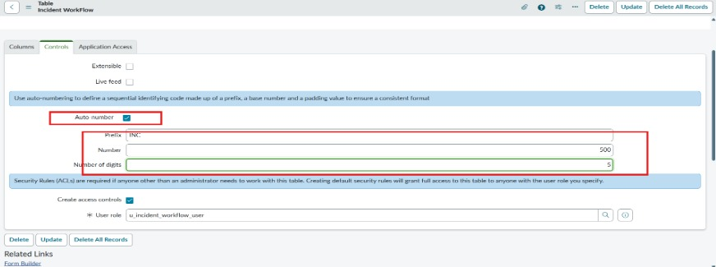
Screenshot 2
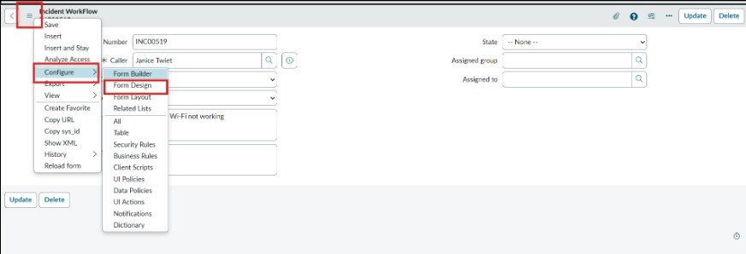
Screenshot 3
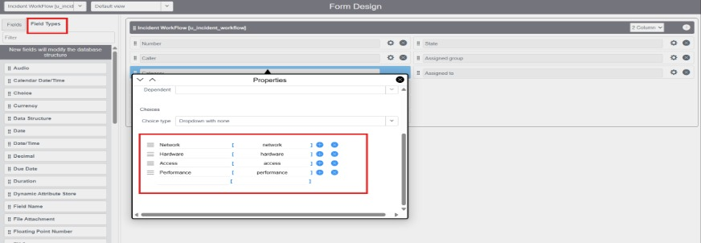
Data Flow Diagram
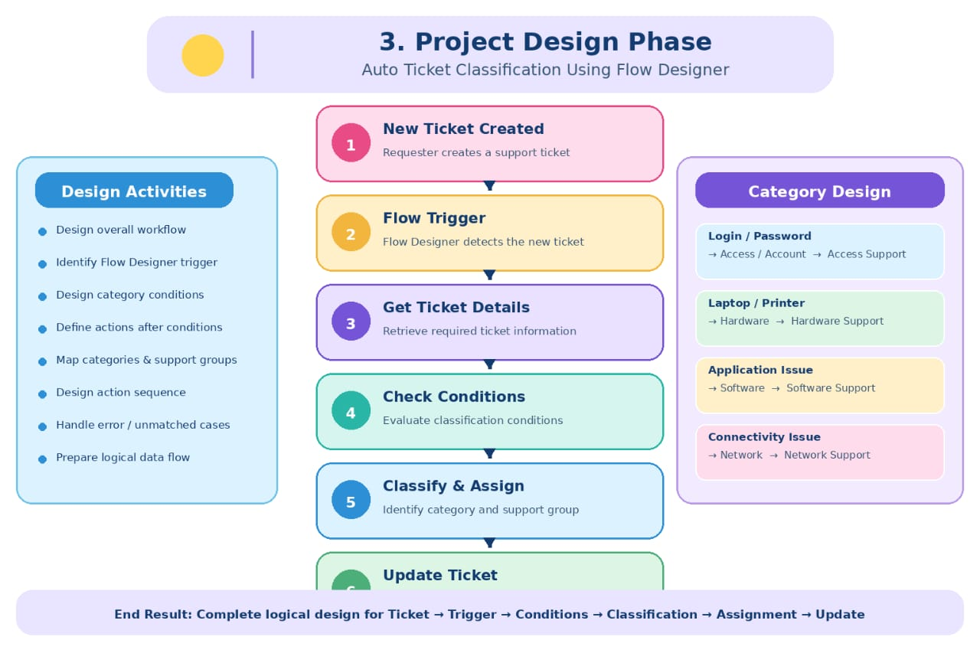

Conclusion

The project design phase converts the identified requirements into a structured workflow. The design provides a clear reference for developing the automation in Flow Designer.

